QUIZ RESULTS
MODULE3: SELECTING A CLUSTERING ALGORITHM

No. | Quiz title | Completion Status | Score | Coursera link
1 | Module3_1_Clustering Algorithms | Completed | 100% | Quiz 1
2 | Module3_2_Comparing Clustering Algorithms | Completed | 100% | Quiz 2
3 | Module3_3_Module 3 Quiz | Completed | 100% | Quiz 3

Module3_1_Clustering Algorithms
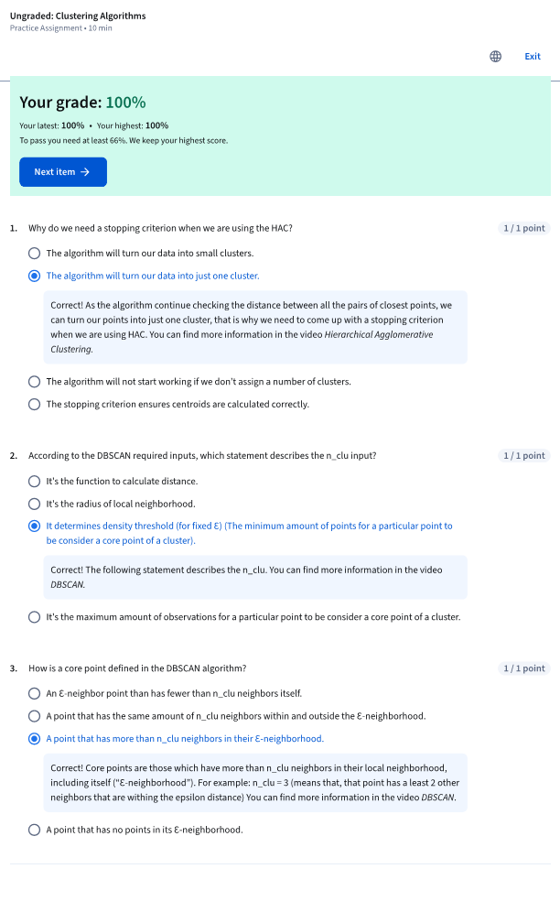

Module3_2_Comparing Clustering Algorithms
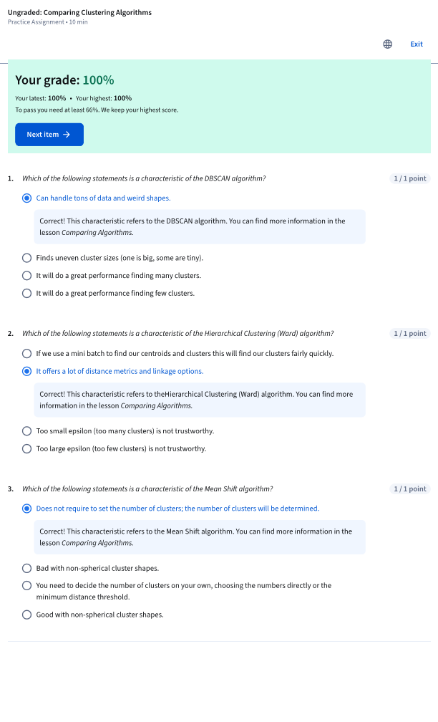

Module3_3_Module 3 Quiz
